Description:

This website is designed to be an online shoe store that sells a few kinds of specialized shoes in varying colors and sizes for both men and women. It also comes with features such as an administrator page that allows modification of inventory, and a checkout page that allows the users to review and modify their selection before checking out.

Site Mockup photos:

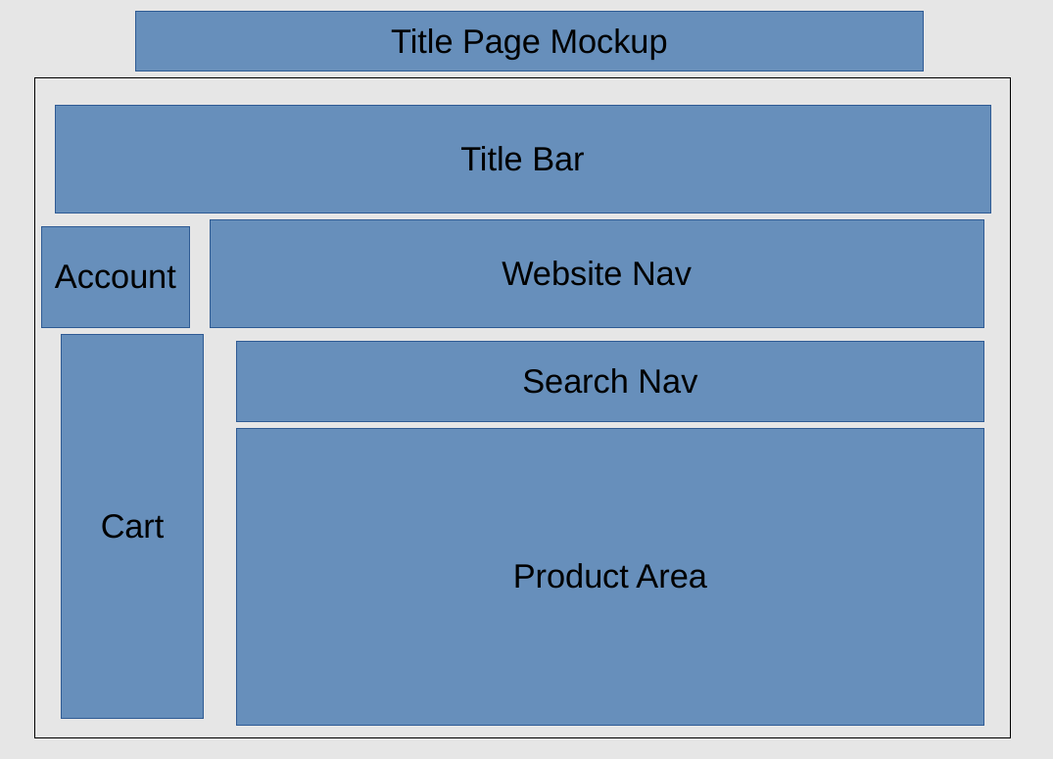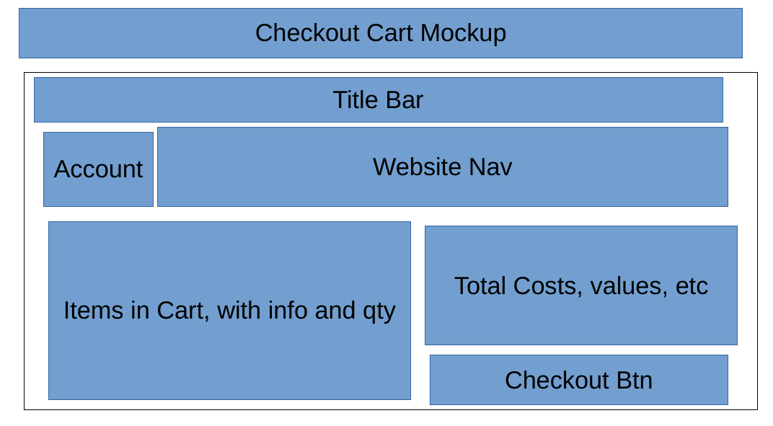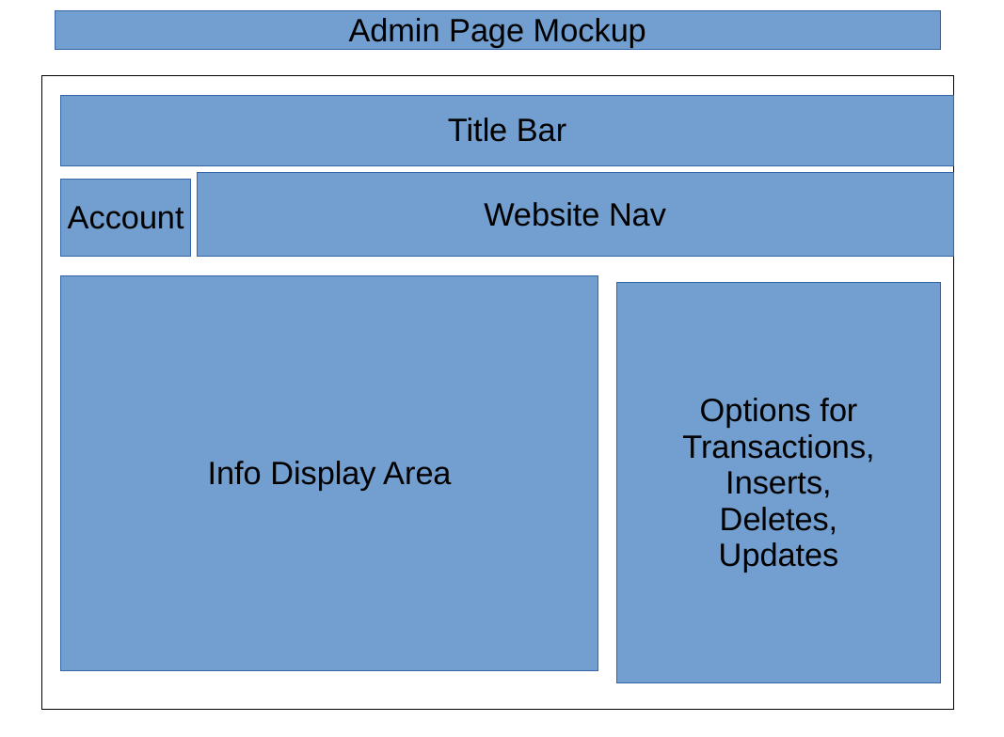

The online user will be met with a product page that will show them all of our products, but then can filter the products down to see only what they want to see using the web controls. This page also contains a button in the upper left-hand corner that will show and hide the cart. As the user adds inventory to the cart, the available quantity will decrease in the product listing.

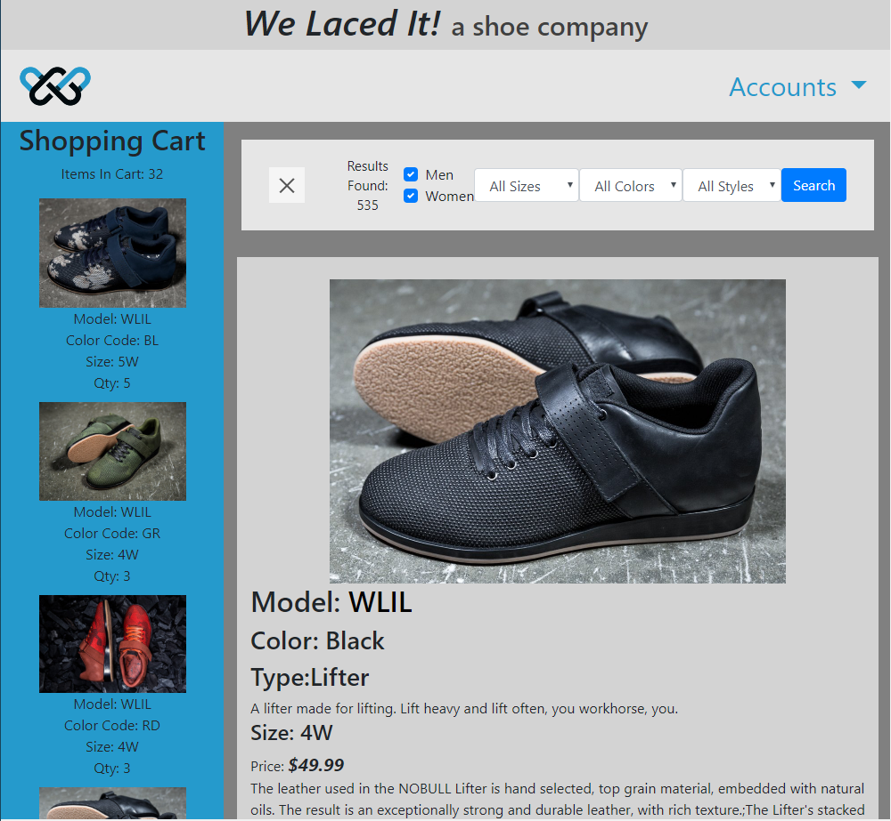

At the time that the user is satisfied with their order, they may press the checkout button which sits at the bottom of the cart

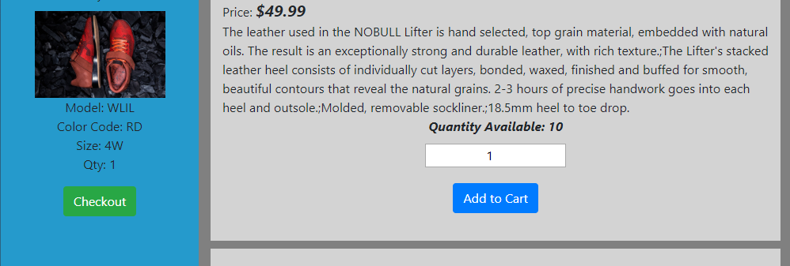

Once at the checkout page, you will see a preview of the item that you have chosen. You will have a chance to update the quantities of the items in your cart or remove it entirely. After you have fine-tuned your cart, you may proceed to complete your order with the complete button at the bottom of the review page.

To maintain the inventory for the website, the administrator will click on the “Accounts” drop-down menu on the upper right-hand corner of each page and choose the “Admin” option. At this point, the administrator will be required to log in.

Upon a successful log in, the administrator will be greeted with a dashboard that gives them the ability to maintain the inventory quantities in the database as well as to view a few inventory and cart based reports.

API and Ajax Calls:

API and Ajax calls are used throughout this website. The most used calls get data from the database. The site uses API and Ajax to get, update, insert, and delete data from the database. This functionality is used on the admin, index, and checkout pages.

The site also uses an API calls to get fake info, using Faker. This data is used on the order complete page, to give a fake buyer name and a fake ship to address. From there, we use another API and Ajax call to convert the “fake” random zip code to a city and a state. The Ajax makes a call through the API, which finds the actual city and state of the given zip code.

These calls, when using Ajax, allow the website to refresh page content without having to reload the page.

Database Design:

The database is designed around the product line that are selling. It has a total of six tables and each table has the following purpose.

|  |  |  |
| --- | --- | --- |
| Table Name | Description of Table | Field Descriptions |
| inventory | All attributes that are associated with the base model of the product are stored here. | |  |  | | --- | --- | | model | Base model of the product. | | model_description | Short description of product. | | model_detailed_description | Long description of product. | | price | Price of product regardless of options. | | type_type_id | Foreign key to type table linking this base product to a specific type. | |
| type | Product types are defined here. | |  |  | | --- | --- | | type_id | Numerical primary key for each type defined. | | type­_description | Short description of product type. | |
| inventory_ quantities | Product quantities are listed here with additional attributes. | |  |  | | --- | --- | | inventory_model | Foreign key to inventory table. | | color_color_code | Foreign key to color table. | | size | Defines numerical size of product. | | gender | Defined gender of the product. | | quantity_on_hand | Quantity on hand for the specific product with certain attributes. | | image_path | Path to product photo within website folder structure. | |
| color | Product color definitions. | |  |  | | --- | --- | | color_code | A two character primary key for each available color. | | color_description | The name or description of the color. | |
| cart | Stores the contents of each user’s temporary cart. | |  |  | | --- | --- | | username | Foreign key to users table. | | sequence | Number that increases to make a uniquely identifiable primary key when combined with the username foreign key. | | quantity_in_cart | Quantity that user has allocated in their cart. | | inventory_quantities_ inventory_model | Foreign key to inventory_quantities for model. | | inventory_quantities_ color_color_code | Foreign key to inventory_quantities for color code. | | inventory_quantities_size | Foreign key to inventory_quantities for size. | | inventory_quantities_gender | Foreign key to inventory_quantites for product gender. | |
| users | List of available users and their permission levels. | |  |  | | --- | --- | | username | Primary key to uniquely identify the user. This is what the user will use to identify themselves. | | first_name | First name of the user. | | last_name | Last name of the user. | | password | Encrypted password of the user. | | admin | Flag to indicate if user is an administrator or not. | |

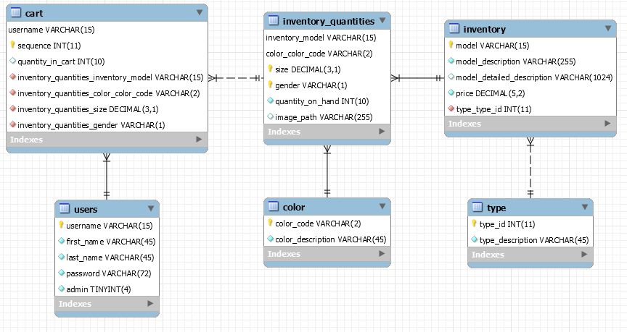

Stored Procedures:

Within the database there are a total of five stored procedures that aid in the functionality of the website and help maintain data integrity and keep performance good.

|  |  |
| --- | --- |
| Stored Procedure Name | Description and Usage |
| transaction_add_cart_item | Add items to the cart table. Ensures that available quantity in inventory_quantities table is sufficient before adding anything to the cart table. This also considers the quantity that already is in the cart table.  Usage:  CALL transaction_add_cart_item("generic", "WLIL", 10, "BK", "M", 1); |
| transaction_checkout | Removes all items for specific user from the cart table and also removes quantity that was in the cart from the inventory_quantities table.  Usage:  CALL transaction_checkout("generic"); |
| getFilteredProductList | Returns a list of product details that are necessary to properly display the search results. This also takes in four optional parameters that allow for a dynamic search result.  Usage:  CALL getFilteredProductList("GR", "M", 1, 10); |
| getInventoryValuation | Will return a list of common reports that all use some form of aggregate function.  Usage:  CALL getInventoryValuation(1); |
| getCartItems | Get a listing of all cart items by the user.  Usage:  CALL getCartItems("generic"); |